Here is a resource that I want you to know about. On our website is an archive of hundreds of Word of the Day devotionals. Every day the daily inspiration is saved to the website. So, there is a vast storehouse just waiting there for you. Here is how you find it.
First, go to Ivey Ministries by clicking here.
You will see a screen that looks like this.
With your mouse, click on the words, Daily Devotional. See circled below.

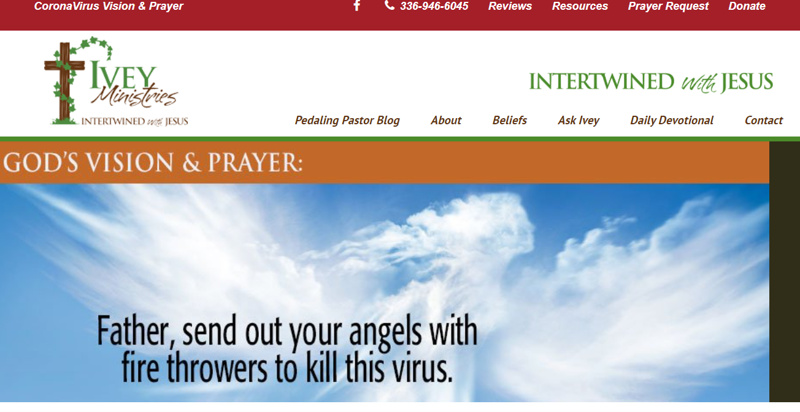
You will be taken to this page:
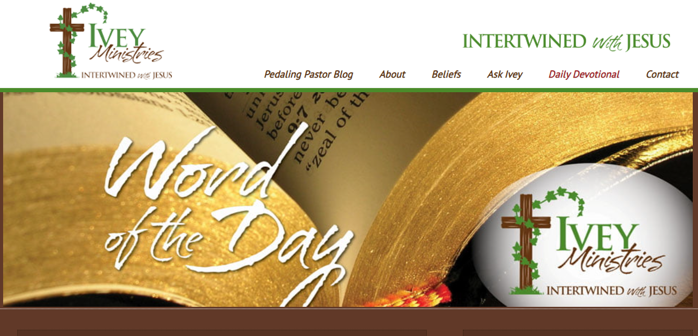
The most recently posted Word of the Day will be just below the banner you see above. Next to the current devotional, on the right hand side you will see this box:
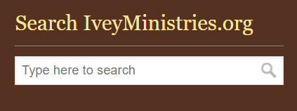
It appears directly below the Ivey Ministries logo.
You can type whatever theme you want in this box, press enter and the search engine will run through the database to collect all of the Word of the Day devotionals that were on that subject. You can also enter a Bible verse in the search field, press enter and all of the devotionals which used that verse will be displayed.
Further down the column is an even better feature and one I use frequently. When you scroll down the page you will see this in the right hand column:
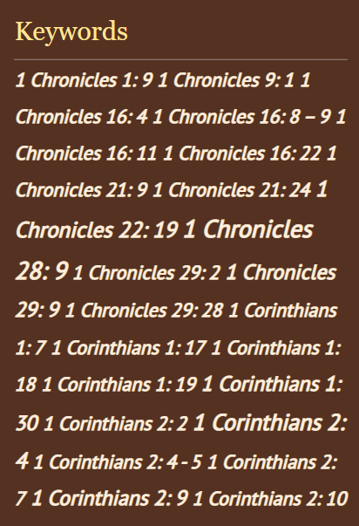
This column continues down the page. It begins with numbers so verse citations that have a number such as 1st Peter or 2nd John are listed at the top of the page. Further down the column you will find other verse citations from the Word of the Day. They are alphabetical and every verse I have used for a Word of the Day since we began the website is there.
Verses are not all that is in this column though. As you scroll further down you will begin to see words. Here is the top of the list:
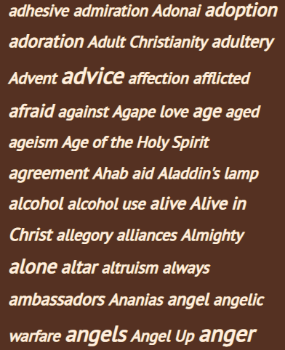
This list goes all the way through Zoe, and it is a list of the keywords used in the Word of the Day. Every Word of the Day devotional is tagged with a number of keywords. For example, if I wrote a post about angels, I would add the words angel and angels as keywords. If a verse is about health and healing, those two words would be used as keywords. The importance of this is that it links specific Words of the Day with Bible verses that have been used in them and the theme of the devotional. Once you find a verse or theme of interest, all you need do is to click on the word or verse right here in this column. When you do, a list of devotionals on that theme (or verse if that is what you selected) will be displayed.
Here is another section of keywords:
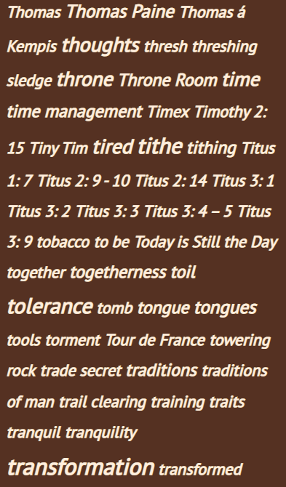
In the above selection, you can see both Bible verses, topics and even people’s names. You may also notice that some words are larger than others. The larger size indicates a topic which has been discussed more often. The larger the print of the word, the more times it has been used as a keyword in the Word of the Day. From this section of keywords, we can tell that I have written on tolerance and transformation more often than on traditions.
Each one of those words and verse citations is a link. If you click on one, it will return all of the Word of the Day devotionals related to that topic or verse. For example, if you click on the word “togetherness” from the list, you will get two messages. The first one is titled He is Here, and the second is Night and Day. Hopefully you have followed along with me and see the search results displayed yourself.

